-------------------------------------------------------------------------------------------------------------------------------NAME: ARCHANA DEVI.P
REG NO: 192521192
COURSE: SOFTWARE TESTING
CODE: CSA0923
LAB PROGRAMS
Question 24: Compare Two Strings Ignoring Case Sensitivity Using Junit
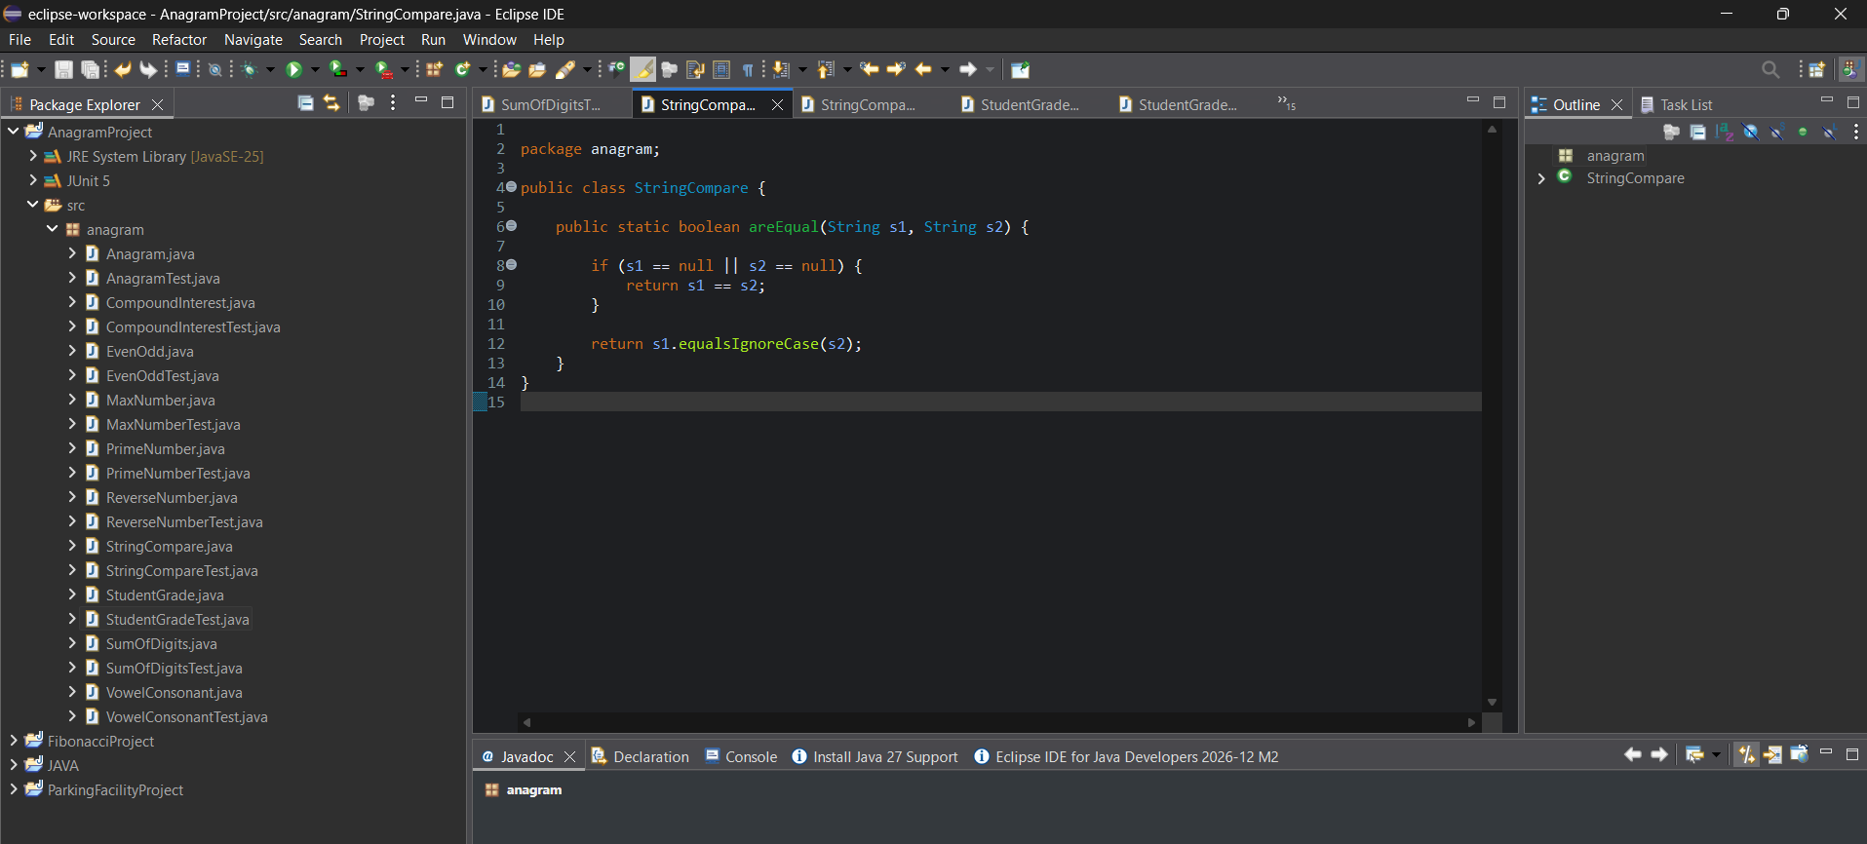
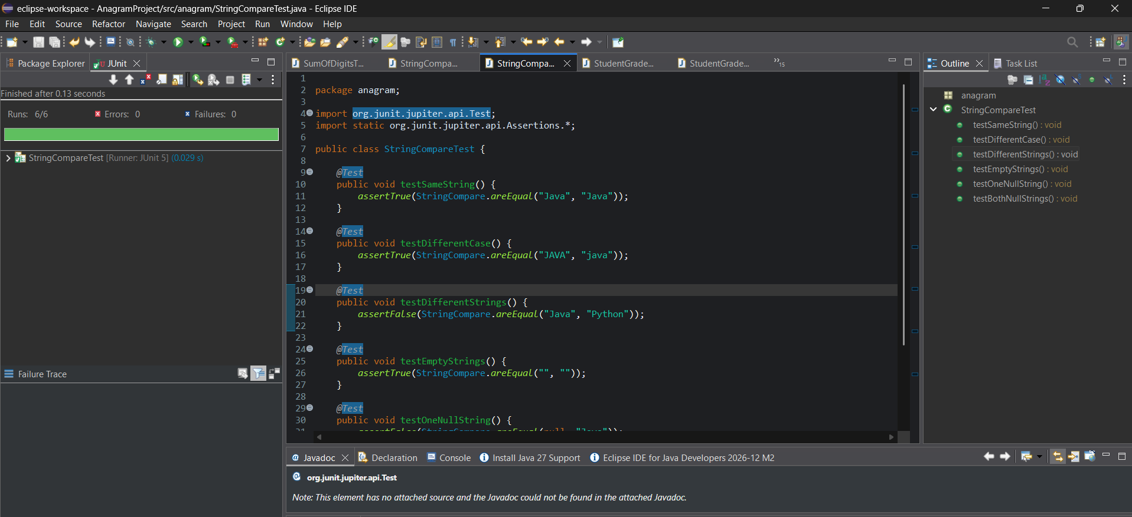
White-box testing
The test cases cover:
- Equal strings.
- Strings differing only in letter case.
- Unequal strings.
- Empty strings.
- One null value.
- Both values being null.
Result : The string comparison program was implemented and tested using JUnit assertions. Six test cases validate case-insensitive comparison and null-handling branches.

